Deployment guide

# 1 Git

If connected to the network of howest:

git clone git@op-gitlab.howest.be:TI/2019-2020/s5-content-management-systems/student-mathijs-vanwymeersch/project.git

# 2 Database

Import dump cms\**mysql183_hosting_combell_com.sql** in a database

Edit the **option_value’s** in the **table wp_options**:  
- siteurl -> option_value = **your website or localhost**- home -> option_value = **your website or localhost**

# 3 CMS

For local use:  
1: Launch WAMP  
2: Put cms\**wordpress** in WAMP\www  
3: browse http://localhost/wordpress/

For online use:  
1: connect to webserver with filezilla  
2: Put cms\**wordpress** in www  
3: browse http://website

## 3.1 WordPress config

1. Login with Administrator (Adminstrator123 as password)  
2. Go to settings and change ’WordPress-adres (URL)’ to **your website or localhost**  
3. Edit the file wordpress/**wp-config**

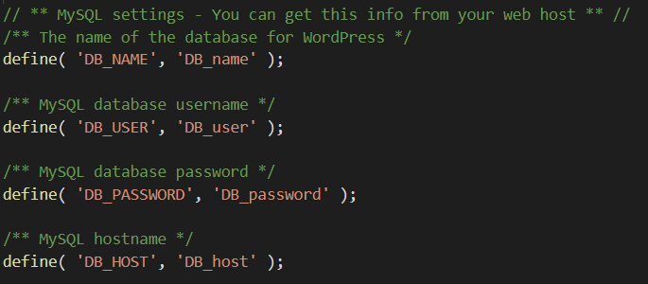

Give the right database name, username, password and host

# 4 PWA

For local use:  
1: Use pwa folder in an editor

For online use:  
1: connect to webserver with filezilla  
2: Put **pwa** in www  
3: browse http://website

## 4.1 Pwa config

Edit pwa\**api.php**

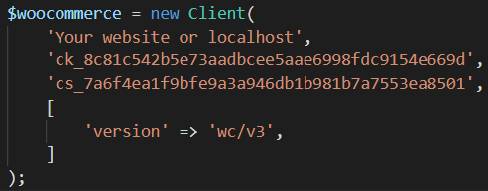

Change the **first** **part** to **your website** or **localhost**